Meeting: | WVONL Board Meeting | Date: |  | November 13, 2025, | Start: |  | 10:46 am
Purpose: | Scheduled Annual Business Meeting | Meeting Format: |  | Oglebay Resort, Wheeling, WV | End: |  | 11:15 am
Lead: | Jennifer Nestor | Recorder: |  | Dawn Yost
Attendance
Present | Jennifer Nestor,  President Elect |  | Present | Sharon Tylka,  Board Member |  | Present | Roger Carpenter,  Board Member
Present | Lya Cartwright-Stroupe, Immediate Past President |  | Present | Tina Powers,  Board Member |  | Present | Jodi Biller, Appointed Board Member
Present | Christine Daniels,  President Elect |  | Present | Cari Morgan,  Board Member
Absent | Brian Versmessen,  Treasurer |  | Present | Jessica Huffman,  Board Member
Present | Dawn Yost,  Secretary |  | Present | Alicia Savage,  Board Member

Time | Topic | Discussion Summary | Follow-up
10:46 am  10:47 am  10:50am  10:51 am | Call to Order | WVONL Annual Business Meeting was called order by Jennifer Nestor.
10:46 am  10:47 am  10:50am  10:51 am | Introduction of Officers & Board Members | Jennifer Nestor introduced the WVONL Officer and Board members, requesting these members to stand as she called their names.  Jennifer noted that Roger Carpenter and Jodi Biller are appointed non-voting Board members.
10:46 am  10:47 am  10:50am  10:51 am | Approval of November 7, 2024, WVONL Annual Business meeting Minutes | Jerry Yoho moved that November 7, 2024,WVONL Annual Business meeting Minutes be approved. Motion seconded by Mary Fanning. Motion carried. | Minutes to be posted to the membership section on WVONL website.
10:46 am  10:47 am  10:50am  10:51 am | President’s Report | Jennifer Nestor presented Power Point slides with the AONL and WVONL Mission and Vision Statements for 2025-2027 side by side to display how WVONL aligns with AONL.  In addition, Jennifer displayed the WVONL Strategic Priorities for 2025- 2027.  Priority: Develop, Support, and Advocate for nursing across the care continuum. Jennifer displayed the WVONL Strategic Plan graphic.  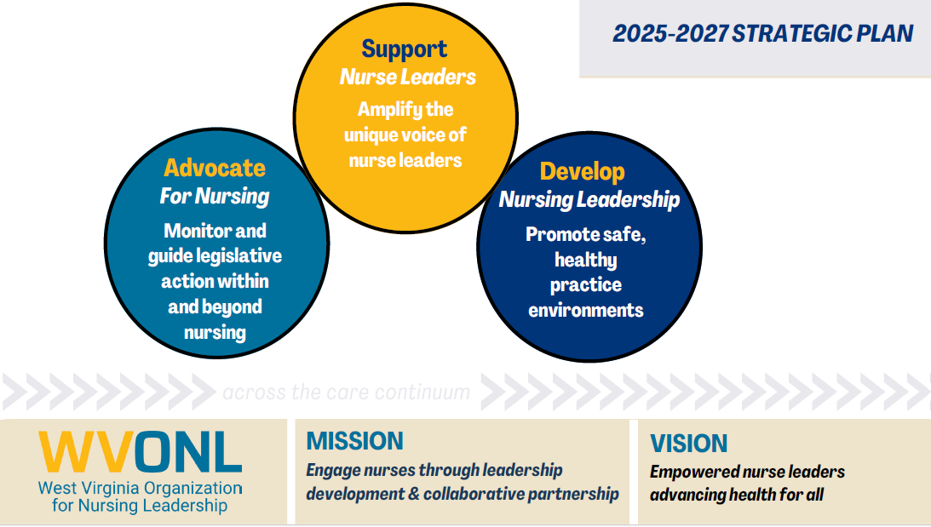  Jennifer discussed WVONL’s affiliation with WV Hospital Association (WVHA)and this affiliation has all WVONL members as affiliate members to WVHA.
10:53am | Finance: Treasurer’s Report | The following slide was presented as the financial report. 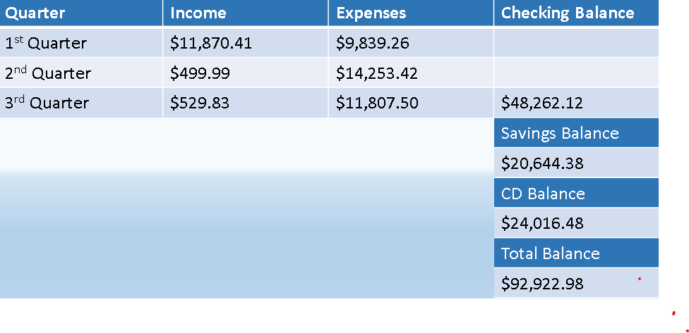 | Additional information is in the annual slide presentation
  Brian Versmessen was not present, and Roger Carpenter gave the financial report as it was presented to him. |  |  | $92,922.98
10:55 am | Committee Reports:  Outreach &Membership Committee  Focus: Programs, implementation, leadership development  Committee Members: Jessica Huffman, Brian Versmessen, Cari Morgan , Alicia Savage, and Jodi Biller. | Jessica Huffman presented th e report of the Outreach &Membership Committee on their social media strategy and future engagement opportunities for nursing students in master’s programs, engagement of nurse leaders in all work settings, alignment with AONL and meaningful award recognition of WVONL members.  Jessica reported that current WVONL membership is at 66 with 7 recurring members.  Jessica announced that WVONL now has autorenewal of membership available for its membership. If you sign up for this then you do not have to be reminded of your membership renewal every October.  Jennifer Nestor thanked Jessica and Cari for their leadership in their committee and contributions during their WVONL Board Term and hoped that they will serve as mentors to future board and committee members. | The Outreach &Membership Committee is looking for volunteers to help lead the social media for WVONL.  Please invite your colleagues to join WVONL and attend conferences.
11:02am  11:06am  11:10 am | Programs Focus: Programs, implementation, leadership development  Committee Members: Christine Daniels, Lya Cartwright-Stroupe, Jennifer Nestor, Sharon Tylka, Roger Carpenter, Alicia Savage, and Cari Morgan | Christine Daniels presented slides on the spring 2025 Virtual Event Series.  WVONL Annual; Fall 2025 event of “ Leading with Purpose: Cultivating Connection, and Courage”. Have 114 registered attendees with 25 registered vendors. Two vendors being platinum status and four vendors being at diamond status  Have 17 posters presented and have four posters presenters from four different hospital campuses who will share a brief synopsis on their poster topic with Q&A forum will be the Ignite Session on Friday morning. | Roger Carpenter obtained nursing contact hours for the conference. WVONL nurse attendees will need to sign in for each day of the conference to obtain nursing contact hours.
11:02am  11:06am  11:10 am | Current Committee Activities: Governance  Focus: Bylaws, strategic plan, nominations, succession planning  Committee Members: Dawn Yost, Tina Powers, Lya Stroupe, and Christine Daniels  Bylaws Change  Election Results | Dawn Yost presented updates for bylaws under Section 6.3Election and Terms were presented and will be voted on by the membership at the WVONL annual business meeting on Thursday, November 13, 2025. The change is:6.3.1.4. To promote broad statewide representation, the leadership of WVONL shall actively recruit and encourage candidates from districts not currently represented on the Board of Directors (see appendix). Candidates from any district may be nominated; however, no district shall remain without representation on the ballot for more than one full three-year election cycle. In identifying nominees, the Committee shall balance geography with demonstrated engagement and leadership within WVONL  6.3.1.5 No officer or director may serve more than ten (10) consecutive elected years in any one office or combination of offices.  Elaine Gerosski moved that the bylaws revisions be accepted. Mary Fanning seconded the motion. Motion carried.  Dawn reported that the voting was extended, and the results of the election are Joey Hodges of District 6 and Bryan Woodford of District 1were elected to the 2026-2029 WVONL Board term.  Jennifer Nestor announced that D’Arcy Alt from District 4 will be a non-voting appointed board member for the 2026-year.  Dawn extended an invitation for WVONL members to join any of the committees that they may have an interest in working on during the year. | Proposed bylaws change is to be inserted as 6.3.1.4 of the bylaws and then make the current 6.3.1.4 then be 6.3.1.5.
11:13am | Installation of Board members | Jennifer Nestor installed Joey Hodges as a 2026-2029 WVONL Board member.  Additional board members Bryan Woodford and appointed Boars Member D’Arcy Alt will be installed at a future WVONL Board meeting. | Mr. Hodges,’ Mr. Woodford’s, and Ms. Alt’s board term will commence in January 2026.
11:14 am | WVONL Spring Conference | The Spring WVONL 2026 Conference will be at Flatwoods, WV on Friday, April 24, 2026. | More to come from programs committee
11:14 am | WVONL Annual Fall Conference | WVONL Annual Fall Conference At Stonewall Resort on November 19-20, 2026. | More to come from programs committee
11:14 am | AONL Conference | AONL Annual Conference will be in Chicago, IL March 29-April 1, 2026.
11:15am | Adjournment | Lya Stroupe moved to adjourn the annual meeting , Jerry Yoho seconded the motion . Motion carried.

